ICE database

-biogenic carbon storage and carbon sequestration excluded from data

-cradle to gate

-fuel related carbon emissions included

**Appliances and Internal Fixtures**

**Ordinary vs. Water-Saving (Self-Closing) Taps**

* Global warming potential (sum of all greenhouse gases measured in kg of equivalent CO2) is recorded instead of only carbon emissions.
* Measured using the method developed by the Intergovernmental Panel on Climate Change for a 100-year time horizon (Eq.4) (Heijungs et al., 1992).

IGWP = ODPi x AEi

where IGWP is the global warming potential indicator (kg CO2eq), n is the number of analyzed substances, GWP is the global warming potential of the substance (kg CO2 eq/kg), and AE is the substance emission to air (kg).

* Assessment is centered in Santa Catarina State University in Joinville, Southern Brazil.
* Assumed lifespan of both taps is 4 years
* CO2 eq during the “Use” comes from water usage and heating
* While no model or brand given for either plumbing fixture, the makeup of each is conveyed in the table below:

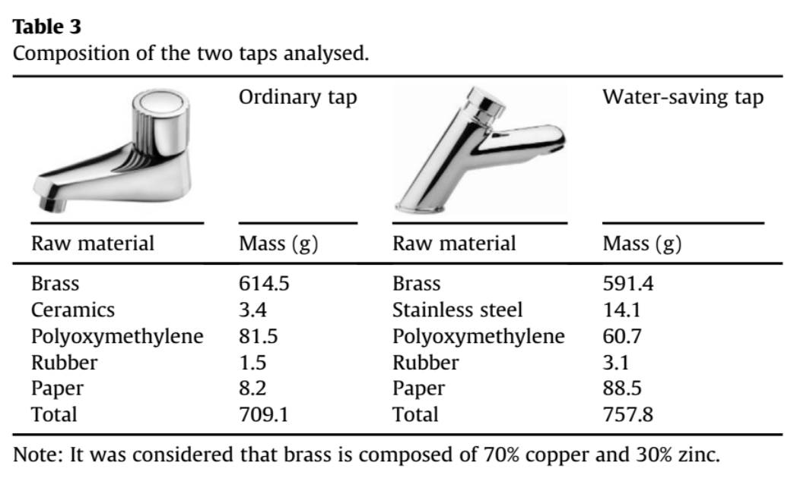

**Toilet Bowl & Showerhead**

* LCA data centered in Japan
* Toilet bowl replaced every 13 years; showerhead every 20
* No model or brand given for either plumbing fixture: assumed generic

**Magnetic vs. Vapor-Compression Refrigerators**

* Specifications for both refrigerators:
  + Energy Efficiency class of A+++
  + Annual energy consumption of 66.17 kWh
  + Subtropical climate (18-38ºC ambient temperature)
  + Refrigeration compartment volume of 223L
  + No freezer compartment
  + Gross volume of 230L
  + Free-standing
  + One door
  + Lifetime of 14 years
* LCA boundary box:

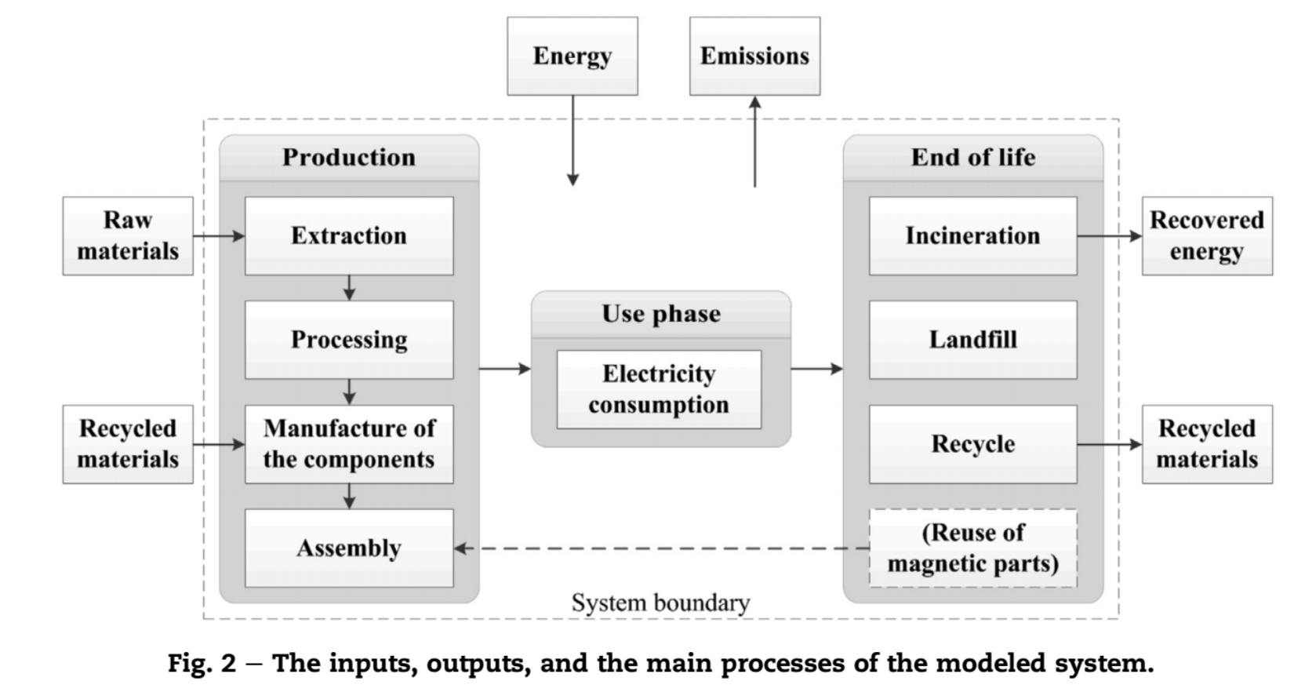

* Refrigerators are assumed to be in Europe
* No model or brand is given

**Household Refrigerators in China**

* Refrigerator specifications
  + Direct cooling double door
  + Compartment volume is 200L
  + Total weight 61kg
* Assesses a *typical* refrigerator in China (again, no model or brand is given)
* Lifetime is 10 years
* Assumed that the refrigerator is kept running 24/h a day ( this only affects the use phase)
* Assumed that the refrigerator is made and used in China
* LCA boundary

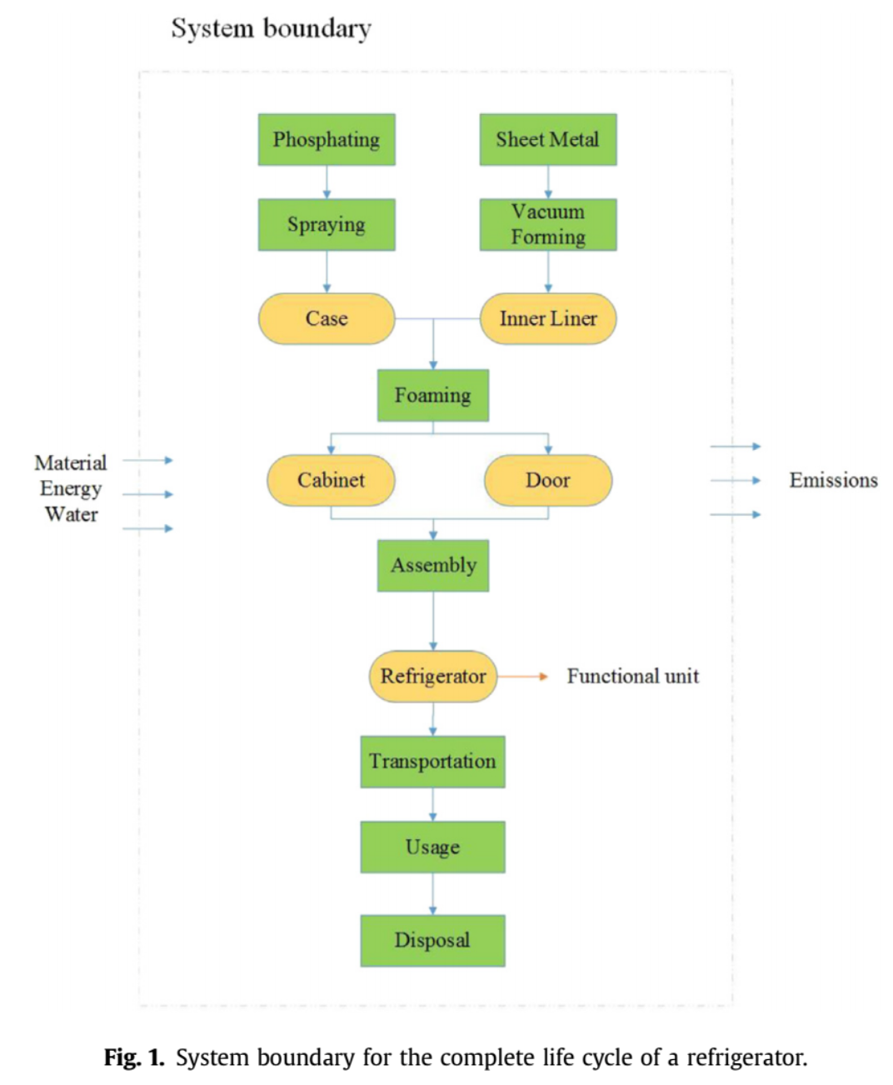

**Chinese Color TV Sets**

* TV specifications
  + 25” diagonally
  + 30kg mass
* kg CO2eq of a single set is derived from a division by 10,000 of the LCA’s original functional unit (10,000 color TV sets)
* Lifetime: 10 years
* “Glass is the main component (51 wt %), followed by steel (12 wt %), copper (8 wt %), aluminium (2 wt %), polyethylene (PE) (1.0 wt %), polyvinyl chloride (PVC) (3.5 wt %), polystyrene (PS) (6.0 wt %), circuit board (3 wt %) and others (3 wt %)”